Appium Vs Expresso

**Key Differences:**

|  |  |  |
| --- | --- | --- |
| **Criteria** | **Appium** | **Espresso** |
| Language | Many | Java |
| App Supported | APK and IPA | APK |
| Test type | Black Box | White Box |
| Speed | 8t | t |
| Setup | Hard | Easy |
| Flakiness of test | Very | Low |
| Used by | QA | Android Dev |

1. **Language**:

Appium allows test scripts written in Java, Python, Ruby, C#, JavaScript, and PHP or any language that supports Selenium, whereas Espresso supports only Java.

1. **App** **Supported**:

Appium offers automated testing on both physical devices and emulators or simulators and allows native, hybrid, and web application testing. It supports cross-platform application testing, which means that a single API may be used to run test scripts on both Android and iOS platforms. It is not reliant on the operating system of mobile devices. (APK, iOS)

Espresso supports only APK.

1. **Speed**:

The difference is that the Execution Time of Appium is much higher compared to Espresso; due to the execution flow of Appium takes the long route for a single command to execute.

Appium Execution flow:

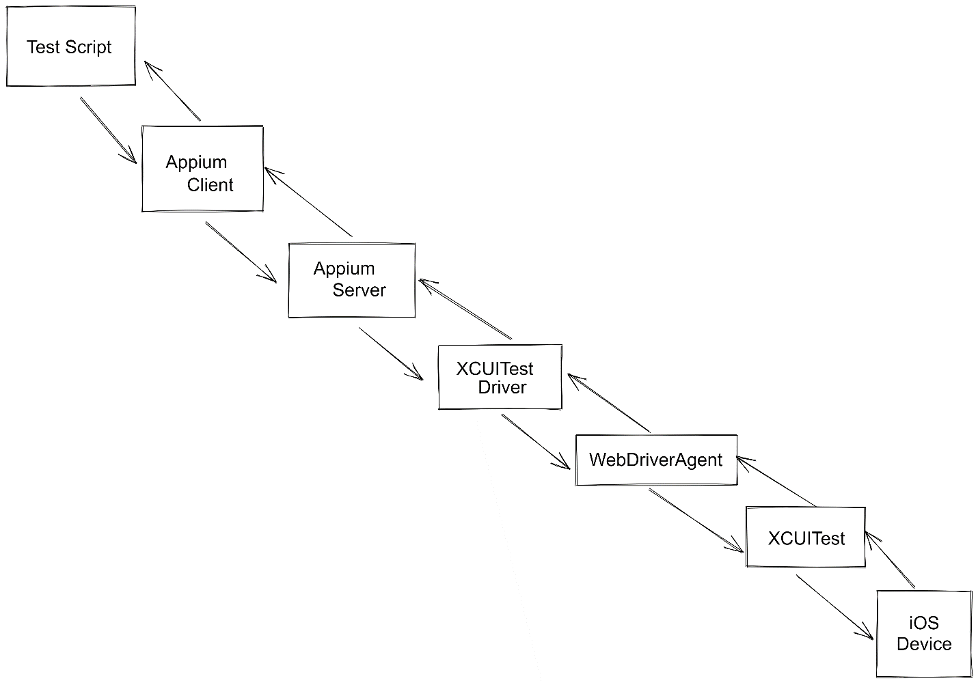

1. **Setup**:

Appium is the hardest to set up, but compared to Appium the setup is easy.

1. **Flakiness of Tests**:

Appium tests are very flaky. Espresso tests are much more reliable as they are native framework

**Summary:**

**Espresso:**

* Used by Developer/ SDET.
* Fast and Reliable.
* Best used for Shift Left testing.

**Appium:**

* Used by QA/Automation teams.
* Full Coverage with better validation.
* Best used for regression testing.

**In My Opinion:**

As we know the Espresso are Native framework for Android automation testing, there is no flaky tests as compared to Appium, because in Appium map/call dial UI changes for each and every device, the Appium test scripts might fail due to the different in UI, but in the Espresso that won’t happen as it’s the Native test Automation framework.

We have to use Espresso for White box testing and for Black box testing, Regression testing we would use Appium.

**Reference:**

